AArete Automation –
Automation of AAreteMonthly reporting for Payment Integrity

Program Evaluation automation
- Program Evaluation of engaged and non-engaged members with match-scores (created separately with the use Principal Component (PCA)). Here, we do demographic analysis and Impact Analysis with ED-Visit, IP-Visit & Cost comparison of engaged with non-engaged groups.

Mobile Health Dashboard
- https://tableau.phs.org/#/site/PHPDEV/workbooks/2723/views
- Summary: This dashboard serves Health Plan Place and Population Health business users to understand from a snapshot and trended view the membership, quality, and annual health wellness visit gaps and capture for the Health Plan Place defined catchment area.
- The population represented in this dashboard are members that are enrolled and active during the reporting time frame in a PHP Medicare Advantage product and live in the Health Plan Place zip code catchment area (87107, 87109, 87110, 87111, 87112, 87114, 87120, 87122).
- Measure Used:
- Membership, Zip Code, Risk Group, Annual Wellness Visit Flag, Member with HCC Gap AND
- Average HCC RAF: At a population level, average year-to-date risk adjustment factor (RAF) score related to the members HCC (hierarchical condition categories)

Outreach Dashboard:
https://tableau.phs.org/#/site/PHPDEV/workbooks/2461/views
It has outreach performance summary with Count of members in Program (like Centralized Outreach & Disease-Management, Outreach Attempt Rate, Engagement Rate. Also, Month wise analysis of Annual Wellness Visit (AWV), Primary Care Visits and HEDIS Measures.

Customer Count Dashboard
The Customer Count is a count of individual non-duplicated "customers" from the three primary business units, PDS, PHP and PMG where the customer is uniquely defined for each of the Business Units.
Counts Include:
- An unduplicated count of individual patients in the PMG seen in the last 18 months,
- plus unique patients in the PDS seen in the last 12 months,
- plus PHP membership for the current month.
- Members and Patients in more than one business unit are counted only once.
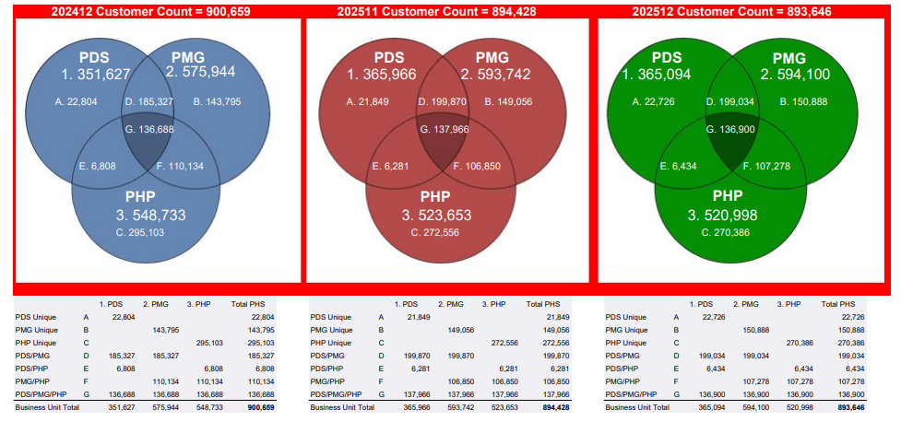
Unite US Data Mapping:
Mapping of various SDOH assessment questions for DataMart.
- “Unite Us Forms Extract Dec 2025_SF Connect Questions” and
- Jiva assessment questions divided by SDOH category

CISC Dashboard
https://tableau.phs.org/#/site/PHPDEV/workbooks/2457/views
Dashboard displays detailed information for the Medicaid CISC population eligible as of the current run month. Areas of exploration include member demographics, cost, utilization, provider coverage, social determinants of health, care management, and Neuroflow engagement metrics.
Dashboard Detail: CISC COEs include: 066, 086
Data and Summary Analysis with following :
- Membership demographics
- ACG metrics like resource utilization bands (RUBs) and number of chronic conditions.
- Cost Profile
- Diagnosis
- Utilization Profile
- Providers
- Social Determinants of Health (SDOH)
- Care Management
- GII : Global Impactibility Index is a statistic created by Presbyterian Healthcare Services which: (1) measures the of over

